SIMATS ENGINEERING
ASSESSMENT TOOL 1

NAME: Siva Dakshitha K REG.NO: 192425395
COURSE NAME: COMPUTER NETWORKS
COURSE CODE: CSA0703

COURSE OUTCOME COVERED

CO4:
Design network topologies star, mesh, bus, and hybrid using networking devices, transmission media, and cabling standards
(BL2,BL6)

Assessment Tool Weightage: 40%

Annexure A

Coding challenge

- Develop a Python program that generates a Star Topology for a given number of hosts connected to a central switch. The program should accept the number of hosts as input and display the topology either in ASCII format or a graphical representation. For each host, print the host label, the name of the central switch, and the corresponding Cat6 UTP cable length connecting the host to the switch. Verify that all hosts are connected through the central switch and explain how the star topology facilitates reliable communication in a local area network.
ANS:
Aim
To develop a Python program that generates a star topology for a given number of hosts connected to a central switch.
Algorithm
- Enter the number of hosts.
- Create a central switch.
- Connect every host to the central switch.
- Assign a Cat6 UTP cable length to each host.
- Display the topology and connection details.

CODE:

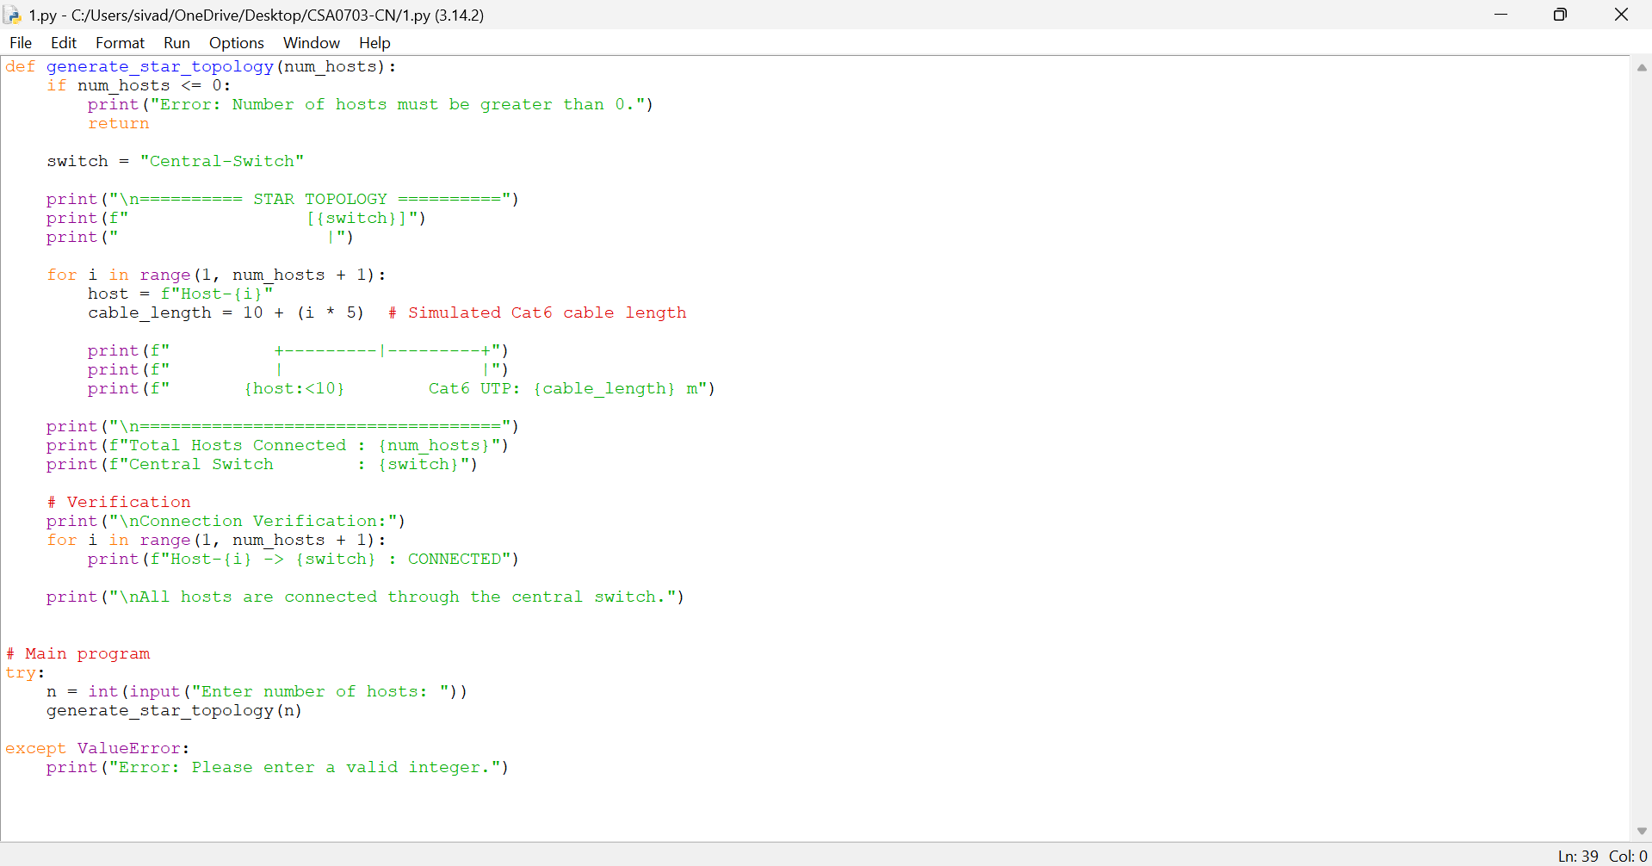

OUTPUT:

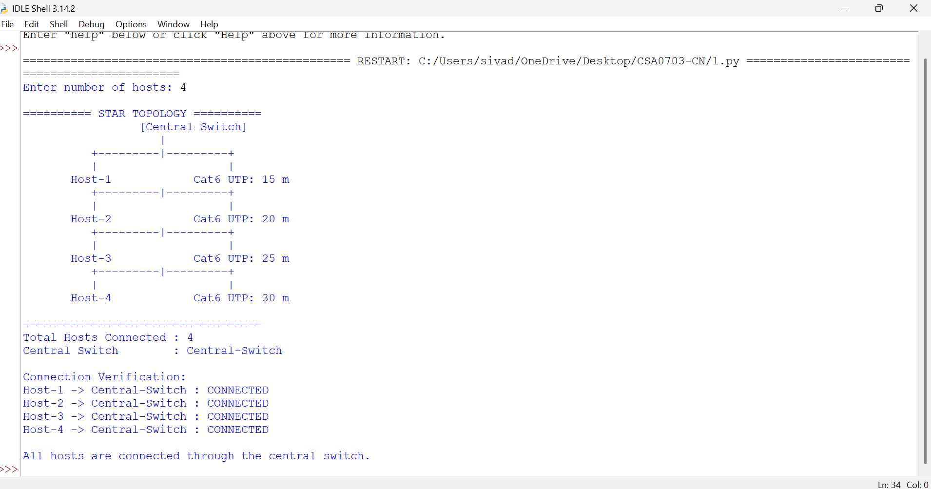

Explanation
In a star topology, all hosts are connected to a central switch. The switch manages communication between the hosts. If one cable fails, only that host is affected, while the other hosts can continue communicating.

Result
The star topology was successfully generated, and all hosts were connected to the central switch with their corresponding Cat6 UTP cable lengths.

- Write a Python function named validate_segment(length_m) to verify whether a given UTP cable segment satisfies the IEEE 802.3 Ethernet standard, which specifies a maximum cable length of 100 meters. The function should return True for valid cable lengths and return False along with an appropriate error message for invalid lengths exceeding the permissible limit. Demonstrate the correctness of the program by executing it with at least three different test cases and interpret the results.
ANS:
Aim
To check whether a UTP cable length is within the maximum 100-meter limit.
Algorithm
- Create validate_segment(length_m).
- Check whether the length is greater than 100 m.
- If it is 100 m or less, return True.
- If it is greater than 100 m, return False with an error message.
- Test the function with three values.

CODE:

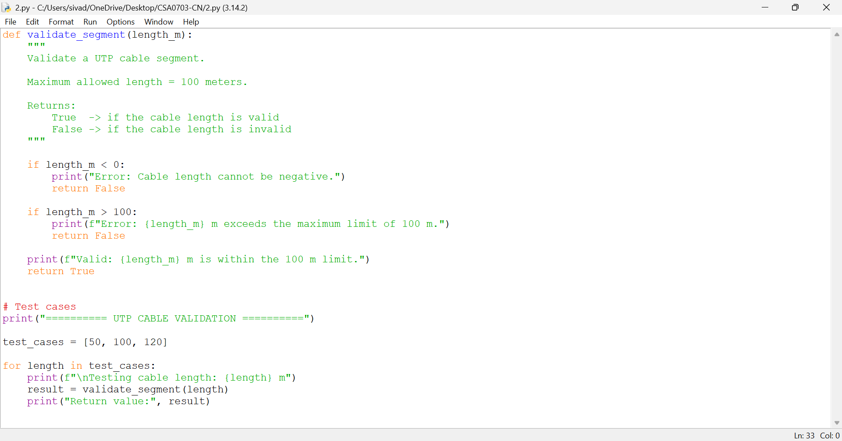

OUTPUT:

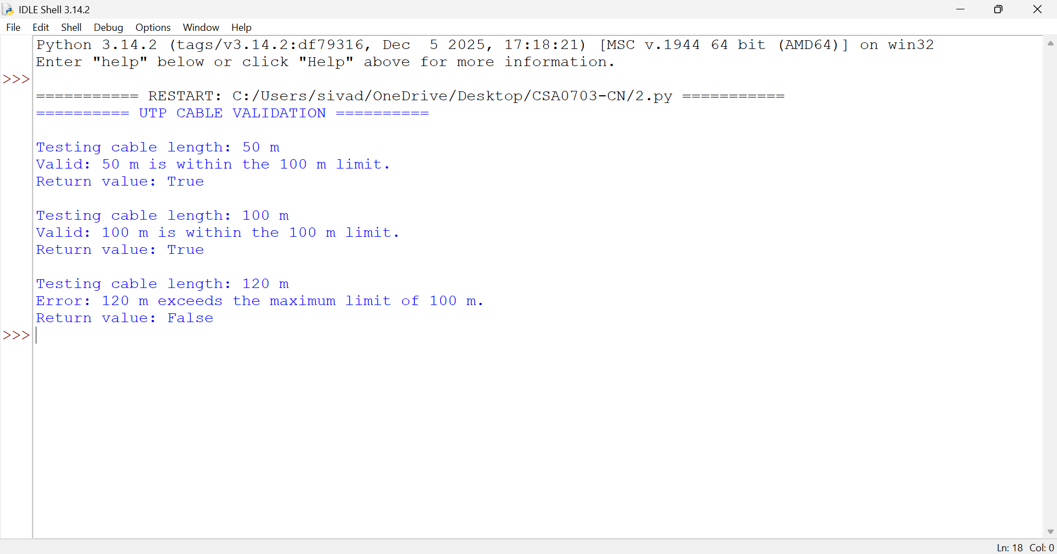
Test Cases
Cable Length | Result
50 m | Valid
100 m | Valid
120 m | Invalid
Explanation
A UTP cable segment of 100 meters or less is accepted. A cable length greater than 100 meters is rejected.
Result
The program successfully validates UTP cable lengths and correctly identifies valid and invalid cable segments.

- Develop a Python program to simulate the operation of the Carrier Sense Multiple Access with Collision Detection (CSMA/CD) protocol in a star topology consisting of four hosts connected through a central switch. The program should simulate frame transmission attempts, detect transmission collisions, calculate random back-off intervals, and continue transmission after the waiting period. Record every collision event, transmission attempt, and back-off interval in a log file named csma_log.txt, and analyze how CSMA/CD minimizes data transmission conflicts in Ethernet networks.

ANS:
Aim
To simulate the CSMA/CD protocol for four hosts connected through a central switch and record transmission attempts, collisions, and back-off intervals.
Algorithm
- Create four hosts.
- Select a host randomly for transmission.
- Check whether a collision occurs.
- If no collision occurs, mark the transmission successful.
- If a collision occurs, calculate a random back-off time.
- Record the events in csma_log.txt.
- Continue until all attempts are completed.

CODE:

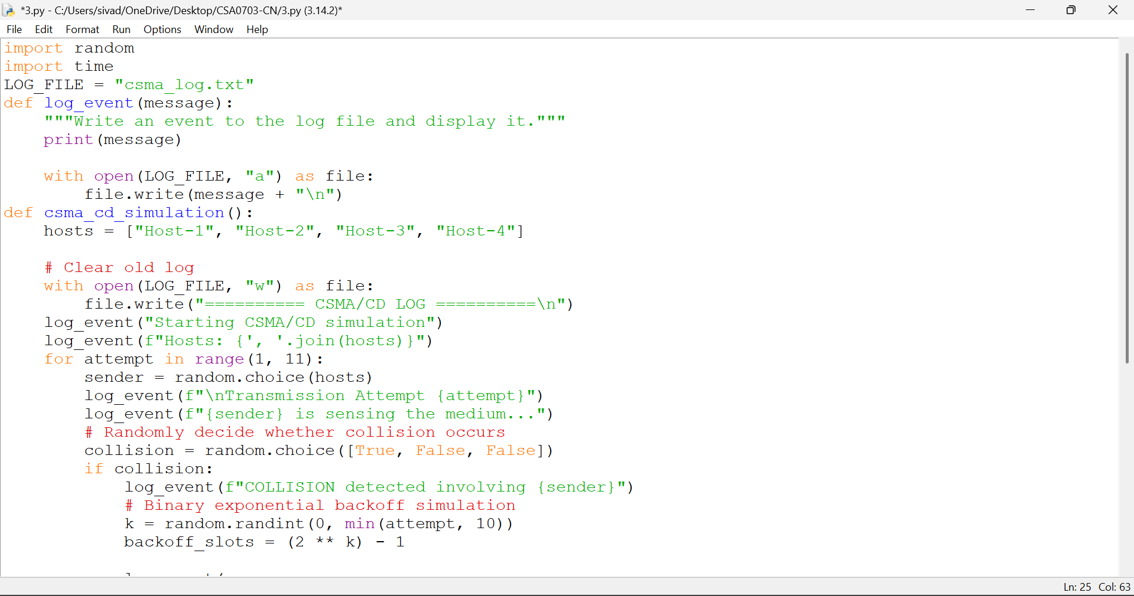

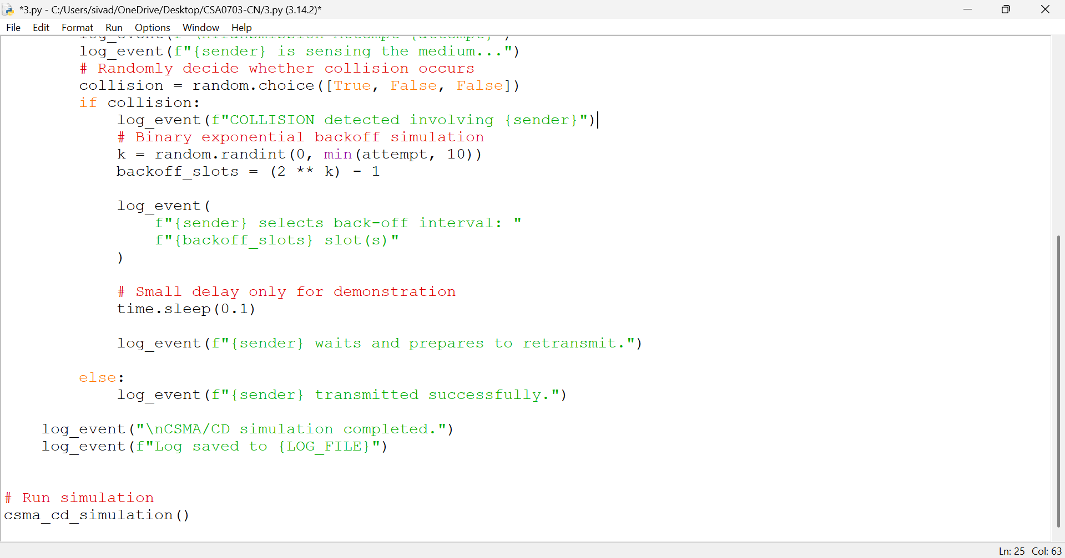

OUTPUT:
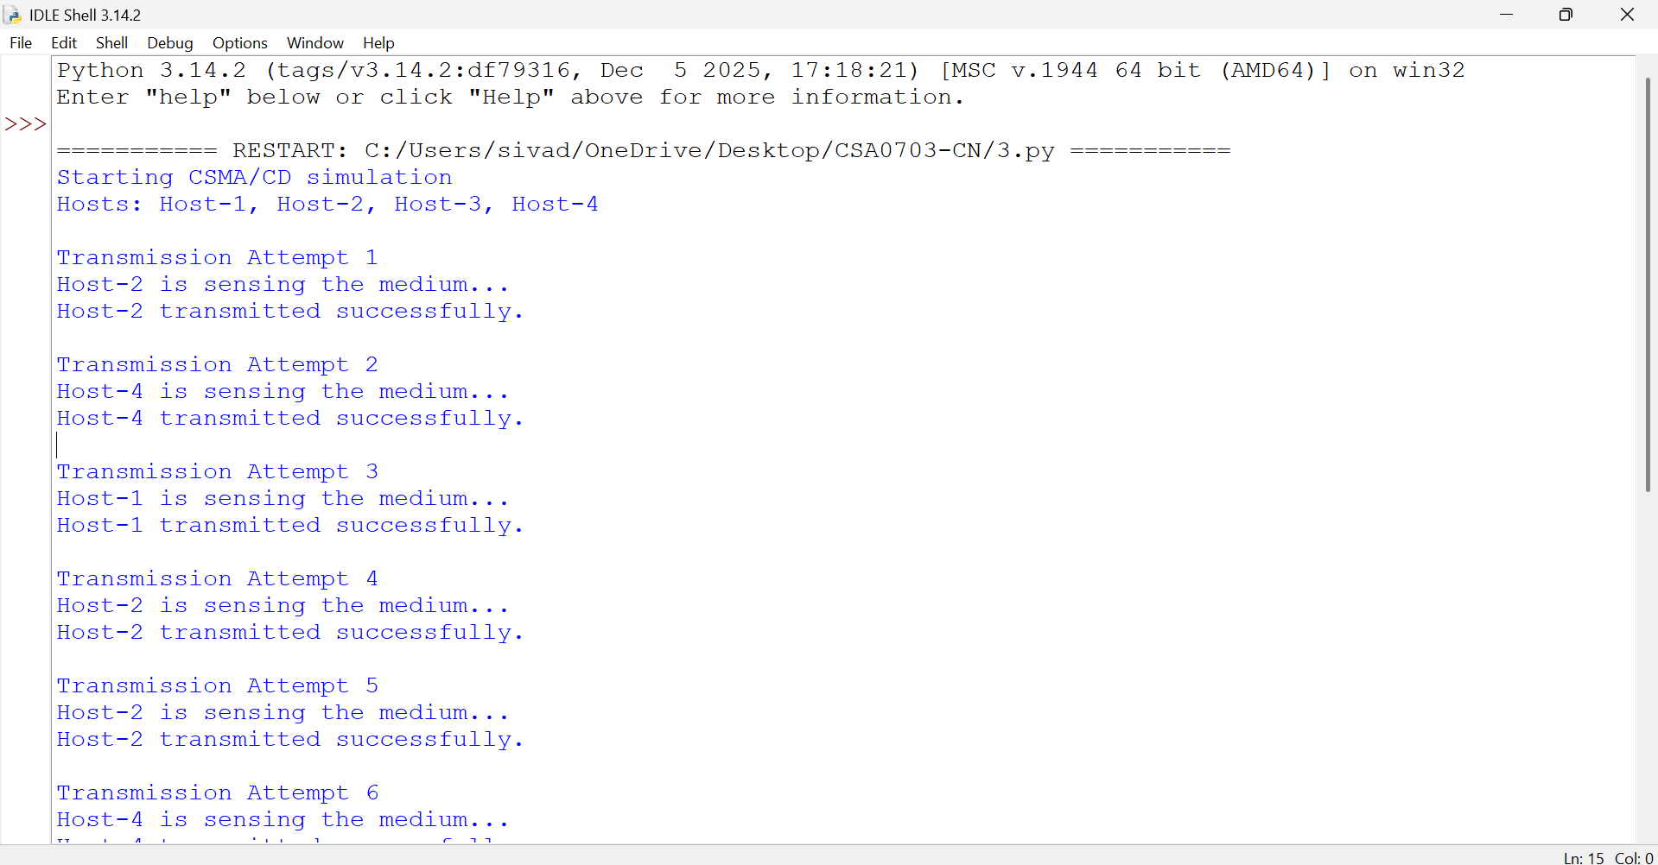

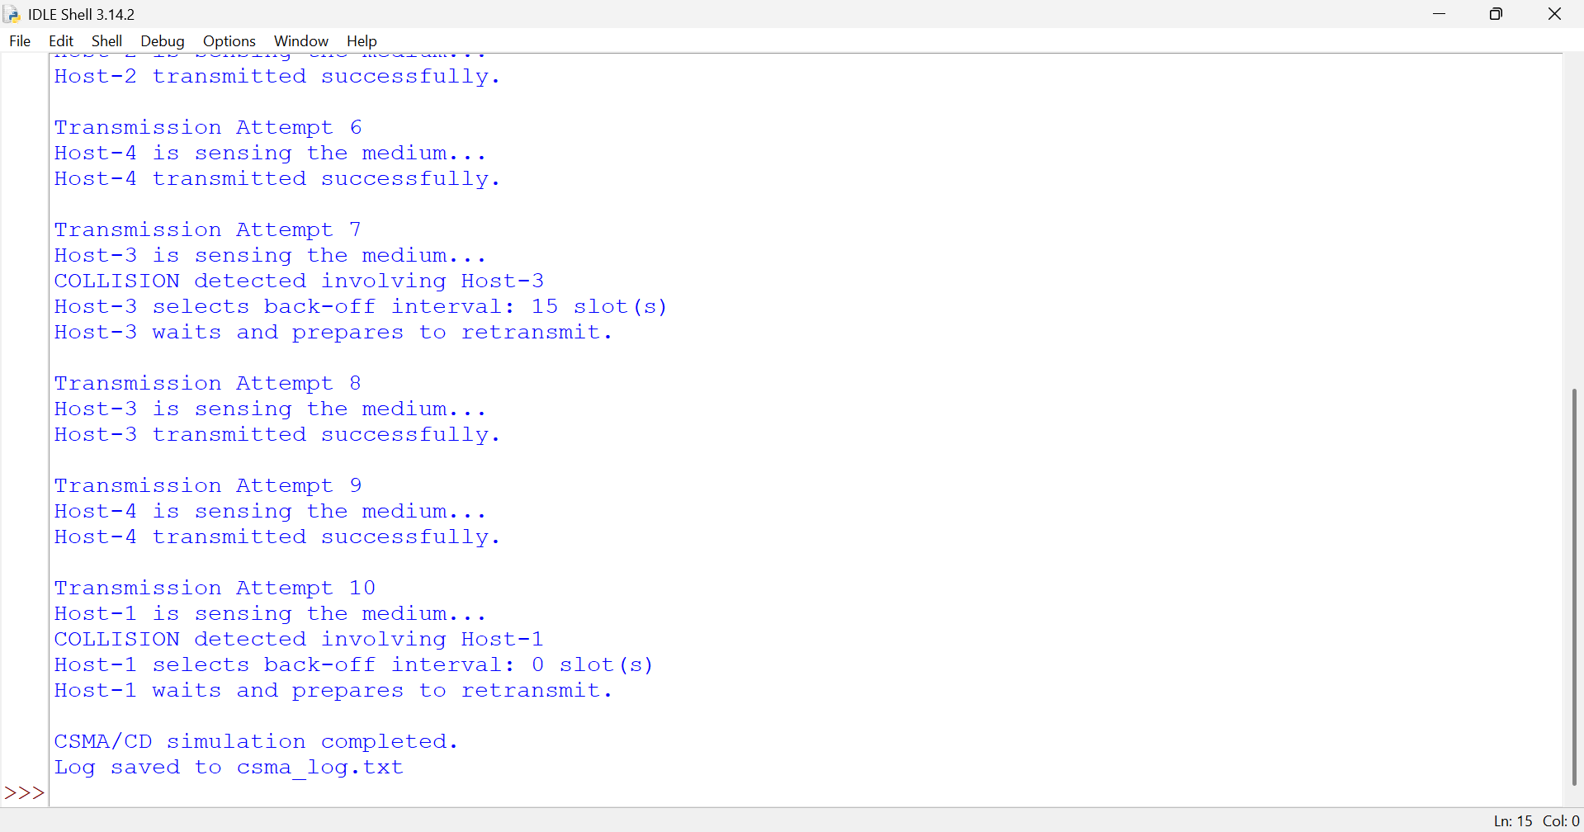
Explanation
CSMA/CD means Carrier Sense Multiple Access with Collision Detection.
When a collision occurs, the host waits for a random back-off interval before trying again. This reduces the chance of repeated collisions.
Result
The CSMA/CD protocol was successfully simulated. Transmission attempts, collisions, and back-off intervals were recorded in csma_log.txt.

- Develop a client-server application using Python's socket library to simulate communication between two hosts connected through a central switch in a star topology. The server should receive frames from the client, forward them appropriately, and maintain a simulated MAC Address Table. After each successful frame transmission, display the updated MAC address table showing the learned MAC addresses and associated ports. Explain how MAC learning and frame forwarding are performed in Ethernet switches.

ANS:
Aim
To simulate communication between two hosts using Python sockets and demonstrate MAC address learning and frame forwarding.
Algorithm
- Create a client and server using sockets.
- Send a frame from the client.
- Read the source and destination MAC addresses.
- Store the source MAC address in the MAC table.
- Forward the frame if the destination MAC is known.
- Display the updated MAC address table.

CODE:

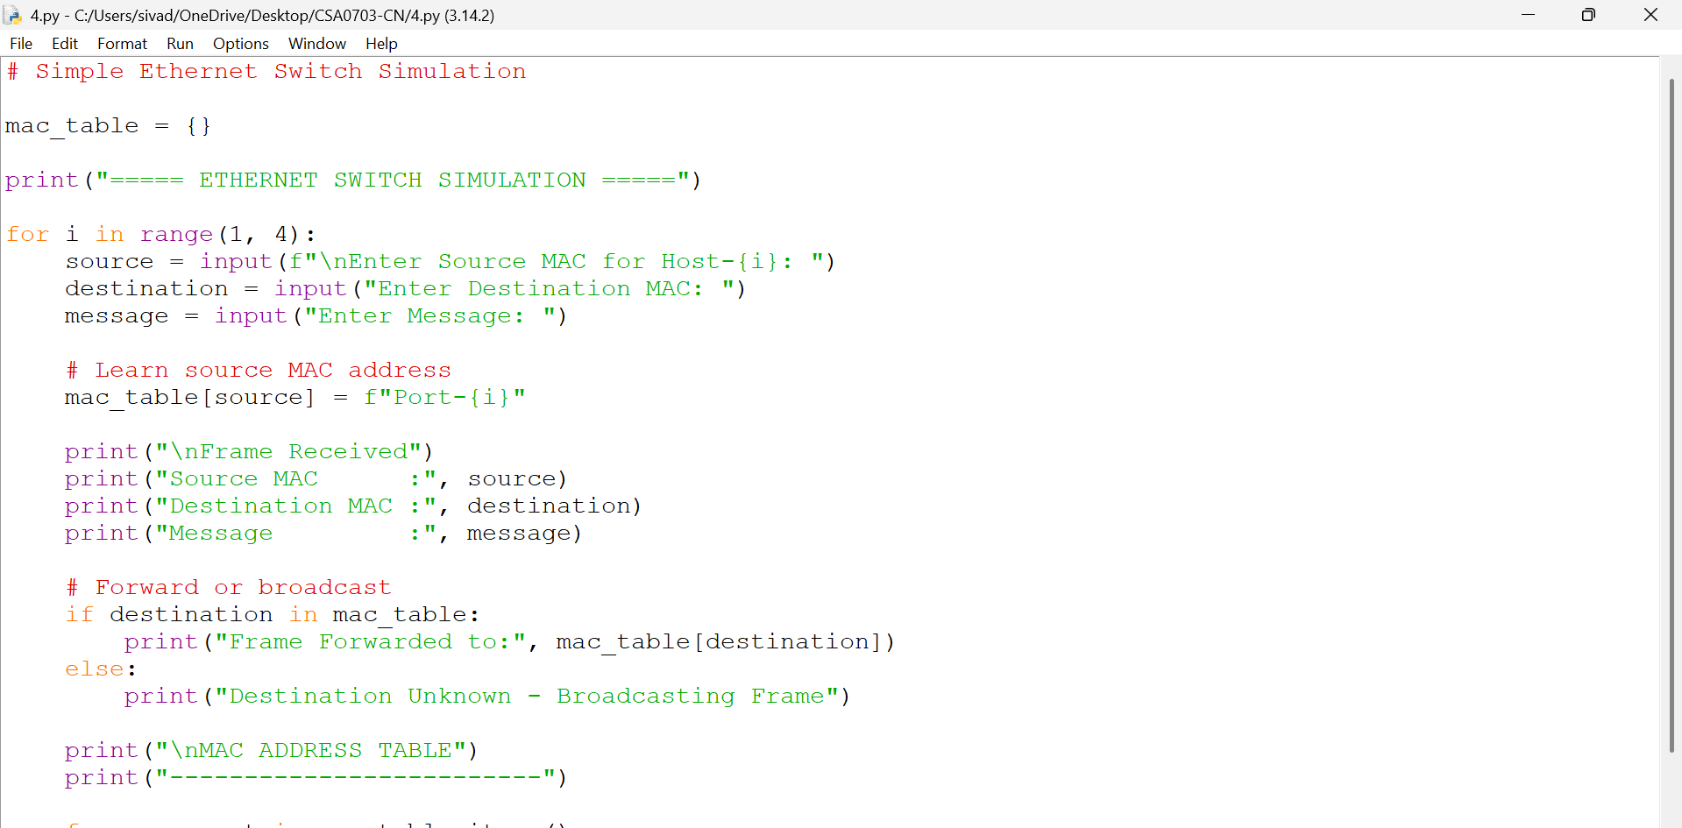

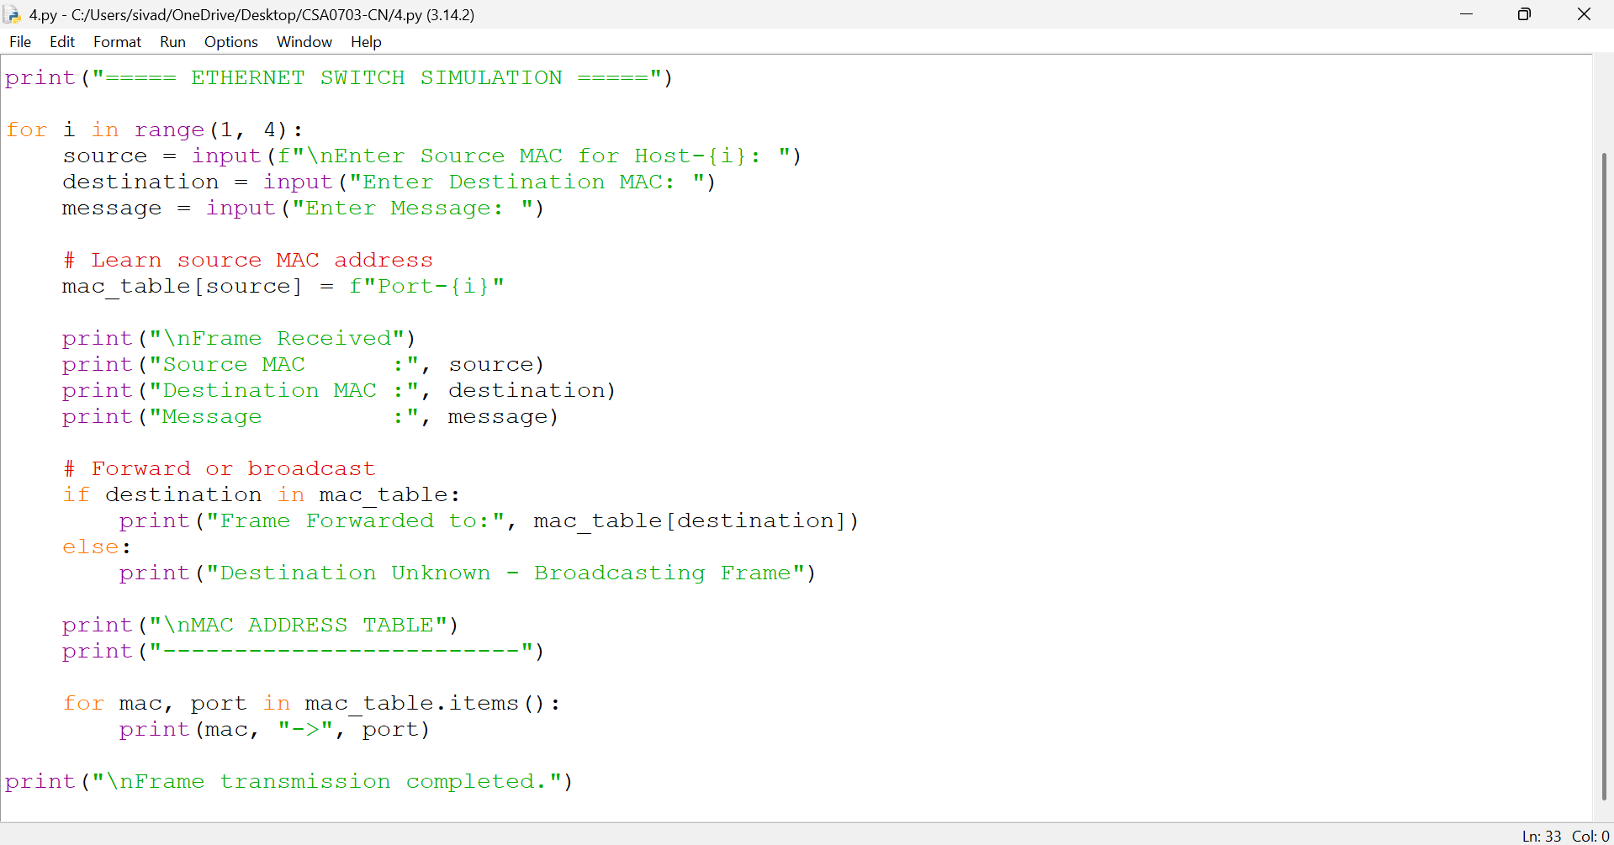

OUTPUT:
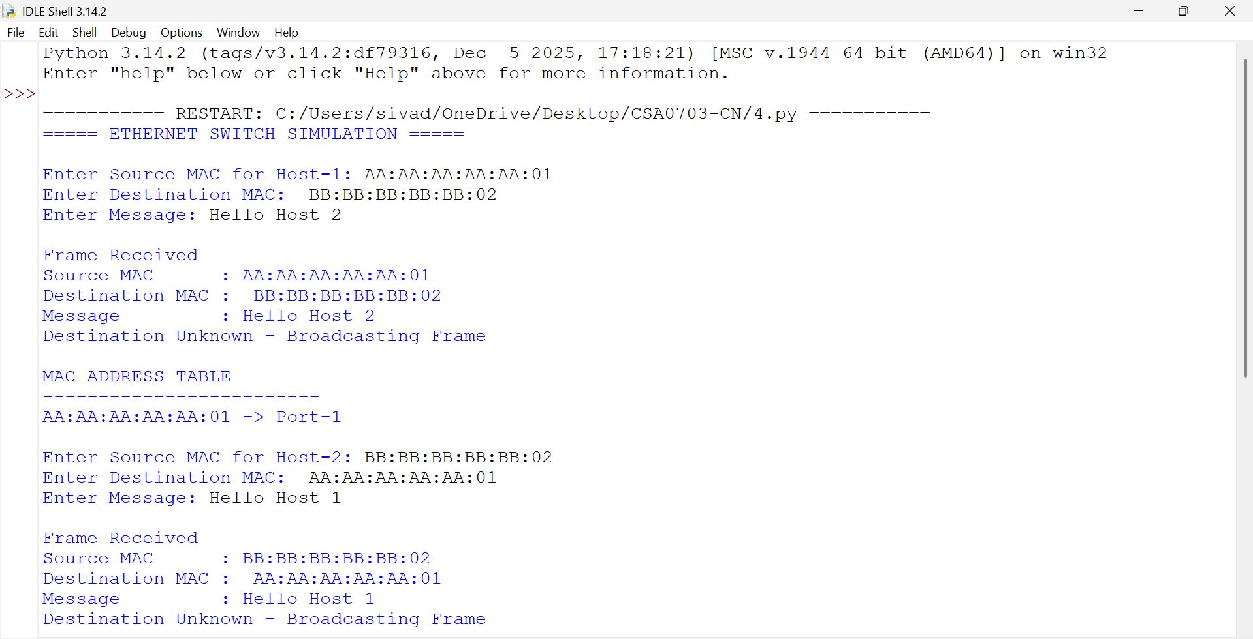

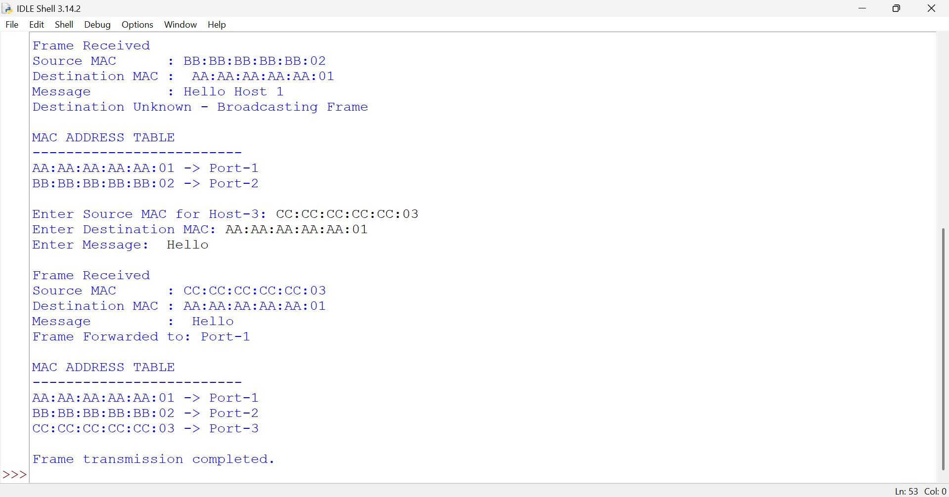
Explanation
The switch learns the source MAC address and stores it with its port. When a frame arrives, the switch checks the destination MAC address.
- Known MAC → Frame is forwarded to the correct port.
- Unknown MAC → Frame is broadcast.
Result
The Ethernet switch operation was successfully simulated, including MAC learning, frame forwarding, and MAC address table maintenance.

- Design and implement a Python class named StarSwitch that models the basic functionality of an Ethernet switch. The class should include methods such as add_port(host_id) to connect a host, remove_port(host_id) to disconnect a host, and broadcast(frame) to transmit a frame to all connected ports except the source port. The program should maintain a record of active ports and log every broadcast operation, indicating the source host and the destination hosts that successfully receive the frame. Demonstrate the implementation using multiple hosts and explain the significance of broadcasting in Ethernet communication.

ANS:
Aim
To implement a simple Ethernet switch using Python and demonstrate adding hosts, removing hosts, and broadcasting frames.
Algorithm
- Create a StarSwitch class.
- Add hosts to the switch.
- Remove a host from the switch.
- Broadcast a frame to all hosts except the sender.
- Display the result.

CODE:
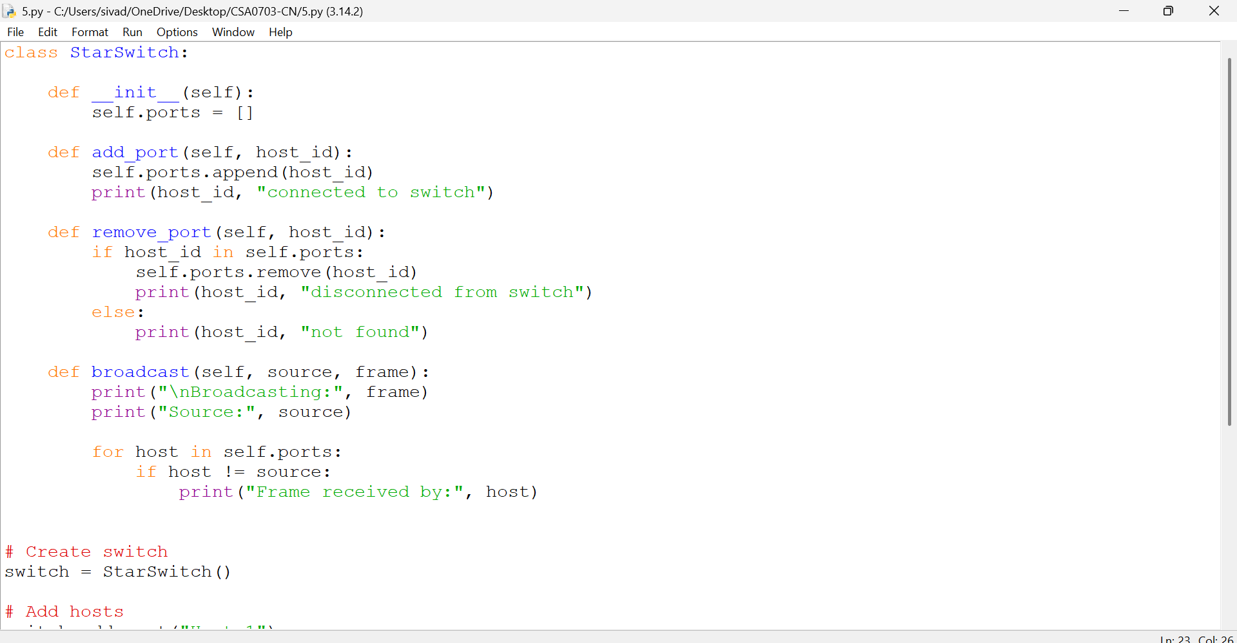

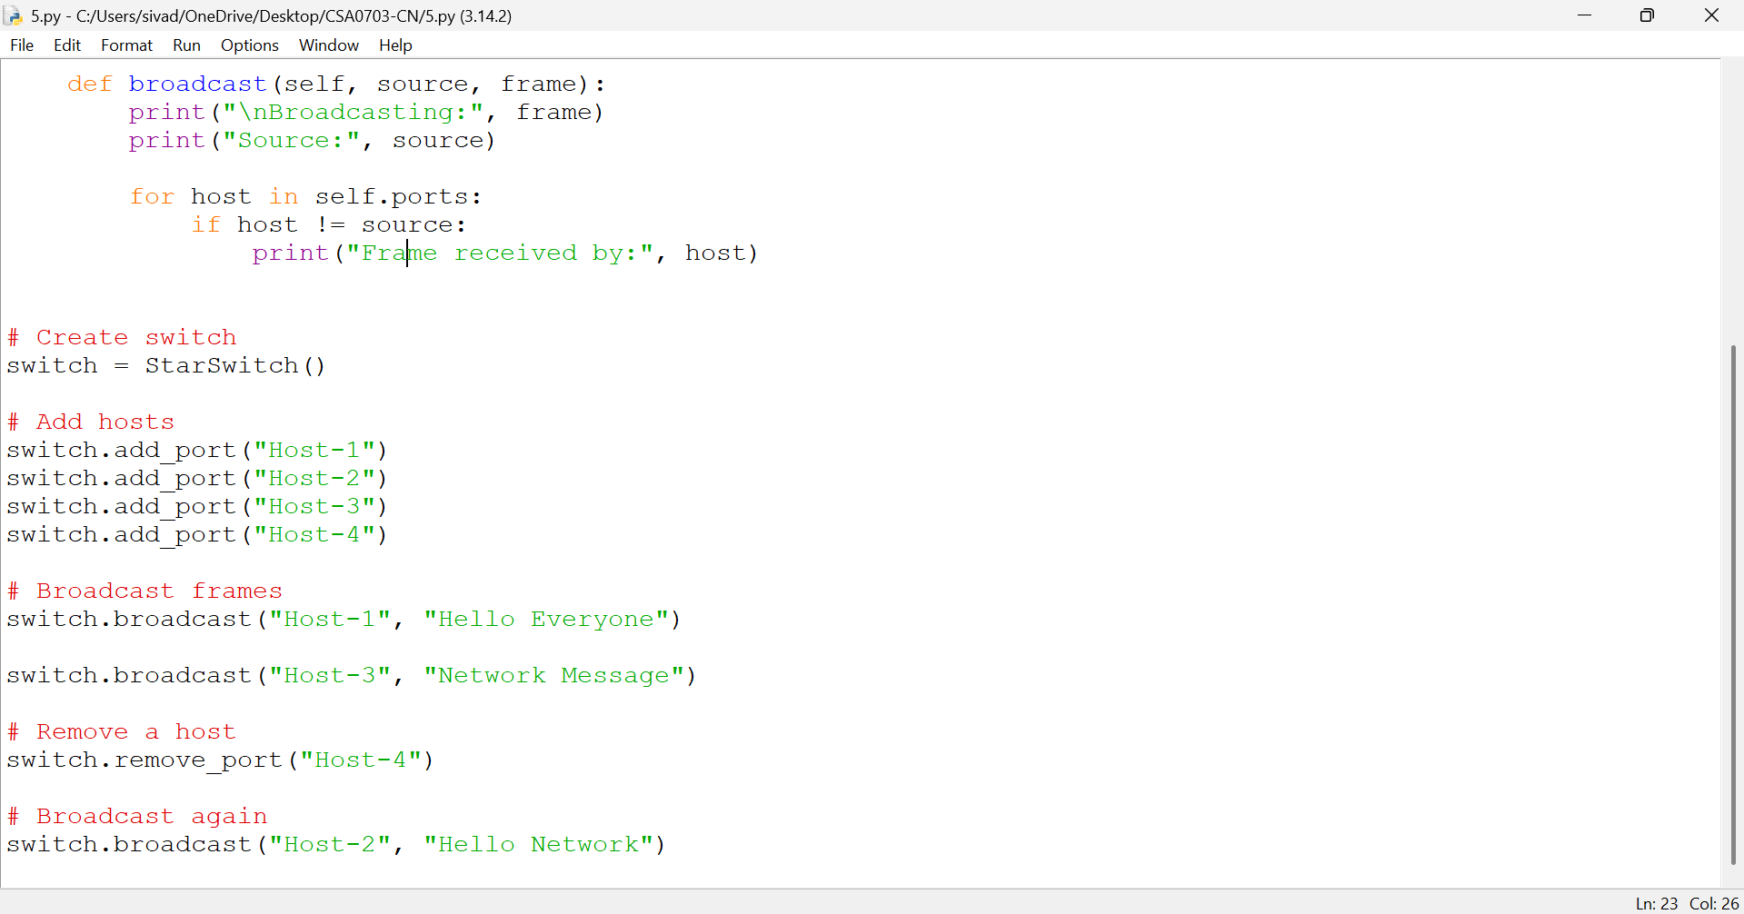

OUTPUT:

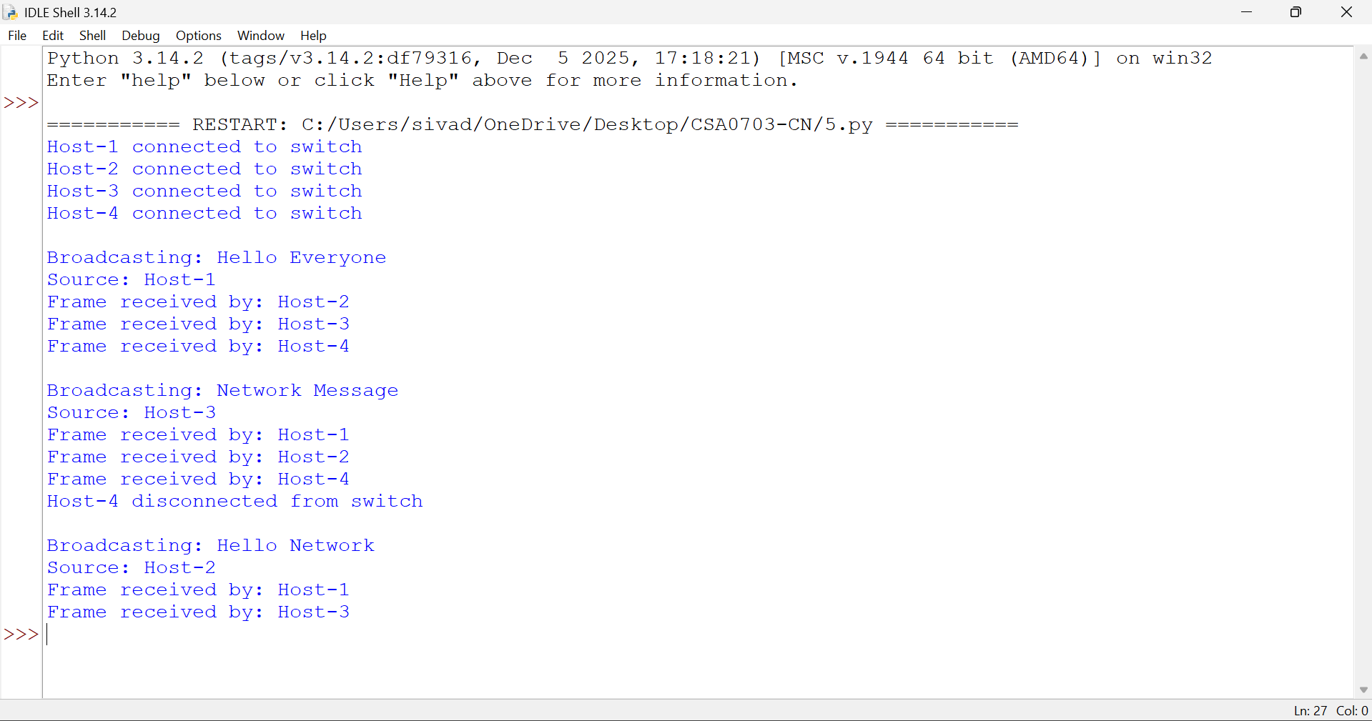
Explanation
The program simulates a star topology where all hosts are connected to a central switch. The broadcast() method sends the frame to every connected host except the source. Broadcasting is useful for Ethernet communication such as ARP.
Result
The StarSwitch class was successfully implemented and tested for connecting, disconnecting, and broadcasting frames between hosts.

RUBRICS FOR CALCULATION

Criteria | Weightage | Exemplary (4) | Proficient (3) | Developing (2) | Beginning (1)
Problem Understanding | 15% | Fully understands the problem and requirements; no clarification needed | Understands most requirements with minor clarification | Partial understanding; misses some requirements | Poor understanding of the problem
Algorithm Design | 20% | Efficient, optimal, and well-structured algorithm | Correct algorithm with minor inefficiencies | Basic approach but not optimal | Incorrect or no clear algorithm
Code Quality | 15% | Clean, well-organized, readable, and properly formatted code | Mostly clean code with minor issues | Code is somewhat unclear or inconsistent | Poorly written, unreadable code
Functionality | 20% | Code works perfectly for all test cases | Works for most test cases | Works for limited cases | Does not run or fails major cases
Error Handling | 10% | Handles all edge cases and errors effectively | Handles some edge cases | Limited error handling | No error handling
Efficiency | 10% | Highly optimized in time and space complexity | Reasonably efficient | Some inefficiencies | Highly inefficient
Documentation & Comments | 5% | Clear and meaningful comments and documentation | Adequate comments | Few or unclear comments | No comments
Testing & Debugging | 5% | Thoroughly tested with multiple cases; no bugs | Tested with some cases | Minimal testing | No testing done

